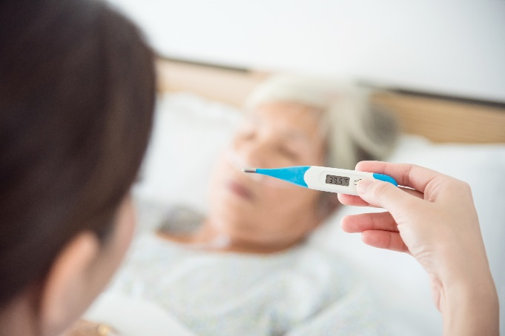
How Flu Can
Make Seniors Frail

Supported by an educational grant from Sanofi Pasteur

For the average healthy person, the flu is no fun by any means, but for seniors 65 and over, the consequences can be devastating.

Being vaccinated for COVID-19 does not protect you from contracting the flu.

Due to the natural weakening of the immune system over time, seniors are at a greater risk of catching the flu. They are also more likely to experience long-term health complications, hospitalization, and frailty if they do get sick.¹

Being hospitalized for a prolonged period can result in older adults losing the ability to care for themselves like they once could. In fact, one-third of seniors who are hospitalized leave not being able to perform their usual day-to-day tasks.

As a result, life can be drastically changed forever, with once active, seniors suddenly facing frailty they never experienced before. This can lead to seniors having to move into long-term care, leaving behind the independence they once had.

The vulnerability a senior can face due to increased frailty has a ‘domino effect’ of negative implications as seniors’ health, relationships and livelihoods are impacted.

The good news is there are steps seniors can take to protect themselves, like getting an annual flu shot.

“Frailty is a growing threat for seniors and our healthcare system as our population ages,” says Dr. John Muscedere, Scientific Director and CEO, Canadian Frailty Network. “That’s why it’s important for seniors to get vaccinated against influenza before flu season hits.”

Canada’s National Advisory Committee on Immunization (NACI) recommends influenza immunization for high-risk individuals, such as adults 65+ and people with chronic diseases⁵.

Vaccination does not provide 100% protection and does not treat influenza and / or its complications or prevent hospitalization or death after the onset of disease.

Haq, K., McElhaney, J. E. (2014). Immunosenescence: Influenza vaccination and the elderly. Curr Opin Immunol, 29,38-42
Monto A.S., Ansaldi, F., McElhaney, J.E., Montano, L.F., Nichol, K.L., Puig-Barbera, J.,Stephenson, I. (2009). Influenza control in the 21st century: Optimizing protection of older adults. Vaccine, 27, 5043-5053
Covinsky, K.E., Palmer, R.M., Fortinsky, R.H., Counsell, S.R., Stewart, A.L., Kresevic, D., Burant, C.J., & Landefeld, C.S. (2003). Loss of independence in activities of daily living in older adults hospitalized with medical illnesses: Increased vulnerability with age. The American Geriatrics Society, 51, 451-458. doi: 10.1046/j.1532- 5415.2003.51152.x
Graf, C. (2006). Functional decline in hospitalized older adults. The American Journal of Nursing, 106(1), 58-67. 5 Public Health Agency of Canada. (2021). An Advisory Committee Statement (ACS)/National Advisory Committee on Immunization (NACI): Canadian Immunization Guide Chapter on Influenza and Statement on Seasonal Influenza Vaccine for 2021–2022. https://www.canada.ca/content/dam/phac-aspc/documents/services/publications/healthy-living/canadian-immunization-guide-statement-seasonal-influenza-vaccine-2020-2021/naci-2020-2021-seasonal-influenza-stmt-eng.pdf

