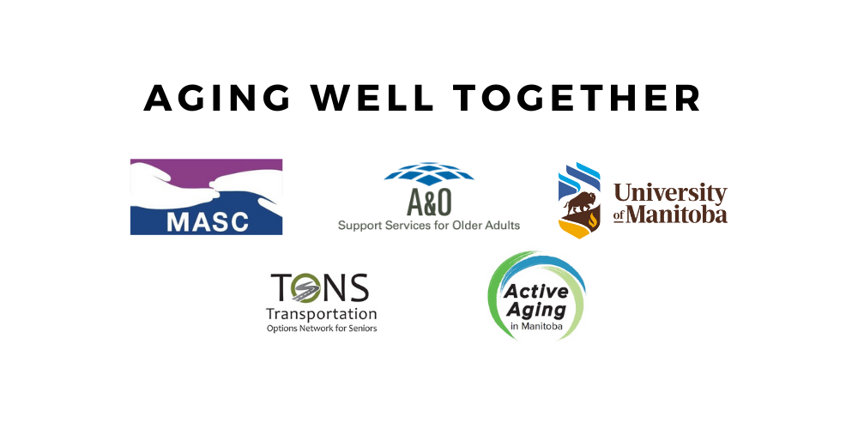

**This partnership is working to reduce social isolation among older Winnipeggers**

**To learn more about our partner organizations and what they do for older adults, please see the following information:**

As an association, MASC is committed to…

...**Facilitating healthy aging connected to community life, for older Manitobans and their families, by integrating program design and delivery of front line services through leadership, learning, connection and community engagement.**

We provide

* Service and support to its member centres and organizations
* Stewardship of the Age Friendly Manitoba Initiative
* Sharing of the voice of older Manitobans
* Strong leadership to front line service providers, undertaking key roles as:
  + Collaborator - working jointly on a project.
  + Enabler - making something possible
  + Facilitator - making an action or process easier
  + Convener - gathering people together.

Our Vision is Age-friendly places (communities) for all

We facilitate healthy aging by providing leadership and encouraging collaboration in creating age-friendly places (communities) that optimize the ability of all older Manitobans to do the things they feel.

**Contact MASC to learn more about their services and connecting with a senior centre near you:**

**Phone:** 204-792-5838

**Website:** [www.manitobaseniorcentres.com](http://www.manitobaseniorcentres.com)

**Email:** [ccnewman@shaw.ca](mailto:ccnewman@shaw.ca)

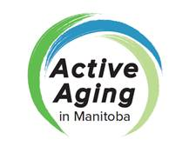**Active Aging in Manitoba (AAIM)** is a not-for-profit organization, dedicated to the promotion of active aging opportunities for all older Manitobans to enhance their health, mobility, and continuing participation in their community.

AAIM strives for the life-long engagement of older Manitobans in healthy choices and behaviours that contribute to physical, social and mental wellness, independence and quality of life through staying socially connected, participating in regular physical activity, eating healthy foods and reducing risk for falls.

Active Aging in Manitoba encourages all older Manitobans to move more and sit less; to connect with and contribute their time, knowledge, and skills to their community; and, to strive toward optimal health for life. AAIM promotes and provides credible information resources, programs and services that encourage older Manitoban participation through peer volunteer leadership development, awareness and education on healthy active aging topics, and management of the annual Manitoba 55+ Games sport for life program.

AAIM continues to seek and develop collaborative opportunities with other organizations, agencies, and individuals to be inclusive and to ensure that every older Manitoban has an opportunity to be a participant in healthy active living.

**Contact:**

Karin Whalen, Executive Director

**Phone:** 204-632-3912

**Email:** [**kwhalen@sogh.mb.ca**](mailto:kwhalen@sogh.mb.ca)

**Website**: [**www.activeagingmb.ca**](http://www.activeagingmb.ca/)

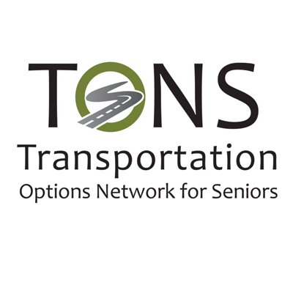

**Transportation Options Network for Seniors (TONS)** is a not-for-profit organization focused on educating and informing community organizations and service providers on the transportation options available to Manitobans, with the goal of enhancing quality of life and promoting age friendly communities. TONS works to provide: tools, presentations, resources an educational opportunity to service providers, health care professionals, policy makers and older adults. This is done through community outreach with current transportation providers both public and private to gain knowledge of the transportation landscape in Manitoba; and by providing education/awareness of these transportation options to the community through group presentations, resources/educational opportunities, and networking. Through our stakeholder networks, TONS educates on the importance of transportation as a main pillar of creating an age friendly community which in turn builds on our mission of promoting quality of life for all Manitobans. Through outreach and community presentations to older adults, TONS gains insight into the experiences of older Manitobans which supports us to provide valuable insight into the transportation needs across our province. Then relays those insights to policy makers within government and health care departments. TONS is appreciative of our many community partners who worked to provide high quality transportation services to older Manitobans no matter where they live.

TONS continues to work toward the goal of addressing transportation gaps for older adults in Manitoba, so we can ensure that all people can age in place with a quality of life they deserve.

**For direct information on transportation options at a community level, please dial 211 to speak to an operator or visit: mb.211.ca**

**Service providers are welcome to contact TONS directly:**

**Email:** [info@tonsmb.org](mailto:info@tonsmb.org) **Phone:** 204-799-1788

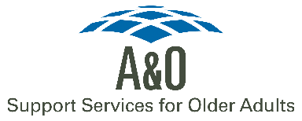

**A & O PROGRAMS & SERVICES**

A & O: Support Services for Older Adults is a not-for-profit organization that provides specialized services for older Manitobans across the province. The goal of these programs is to empower and support older adults in the community.

1. **SAFETY & SECURITY**

1. Elder Abuse Prevention Services

2. Safe Suite Program

3. Older Victim Services

4. SafetyAid: Falls Prevention Program

5. This Full House

1. **SOCIAL ENGAGEMENT**
   1. Senior Centre Without Walls
2. Connect Program

3. Senior Immigrant Settlement Services

1. **COUNSELLING SERVICES**
2. Counselling
3. Information and Referral
4. Intake
5. Caregiving with Confidence- supports informal caregivers in Winnipeg
6. Housing

6. Legal Services

**Contact A & O: Support Services for Older Adults to learn more about their programs and services:**

**Phone**: 204-956-6440

**Toll-free**: 1-888-333-3121

**Website**: [www.aosupportservices.ca](http://www.aosupportservices.ca)

**Email**: [info@aosupportservices.ca](mailto:info@aosupportservices.ca)

NOTE: all calls are strictly confidential

**University of Manitoba**

Researchers at the University of Manitoba and Brandon University support the Aging Well Together Coalition through research and evaluation. With the Targeting Isolation initiative, they further aim to:

* Help people identify and better understand social isolation;
* Train Community Connectors to connect socially isolated older individuals to community resources; and,
* Work with organizations that help reduce older people’s social isolation.

**Website**: [targeting](http://www.aosupportservices.ca)isolation.com

**Email**: [targetingisolation@brandonu.ca](mailto:targetingisolation@brandonu.ca)

**Phone:** 204-272-3184